功能：
Cifar10 keras训练 采用pycharm+docker开发模式

安装配置
方法参考：
005 PyCharm+Docker+.doc
超图北京GPU
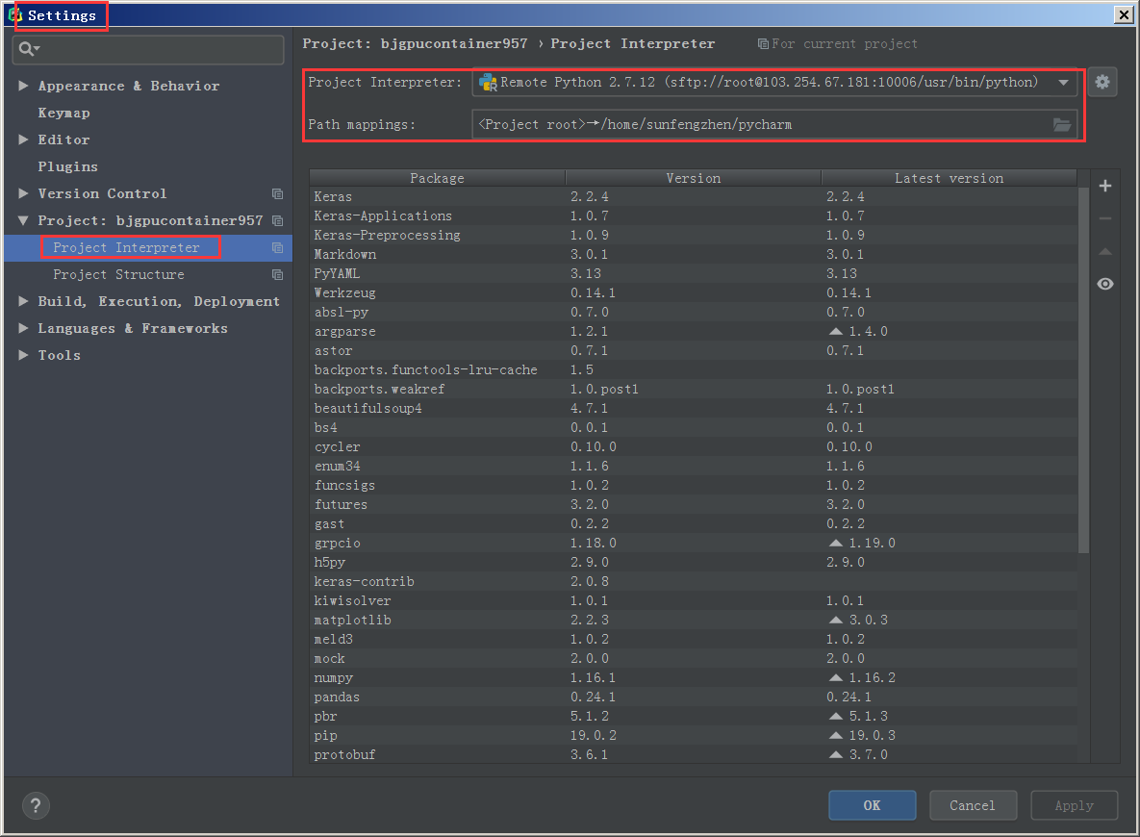
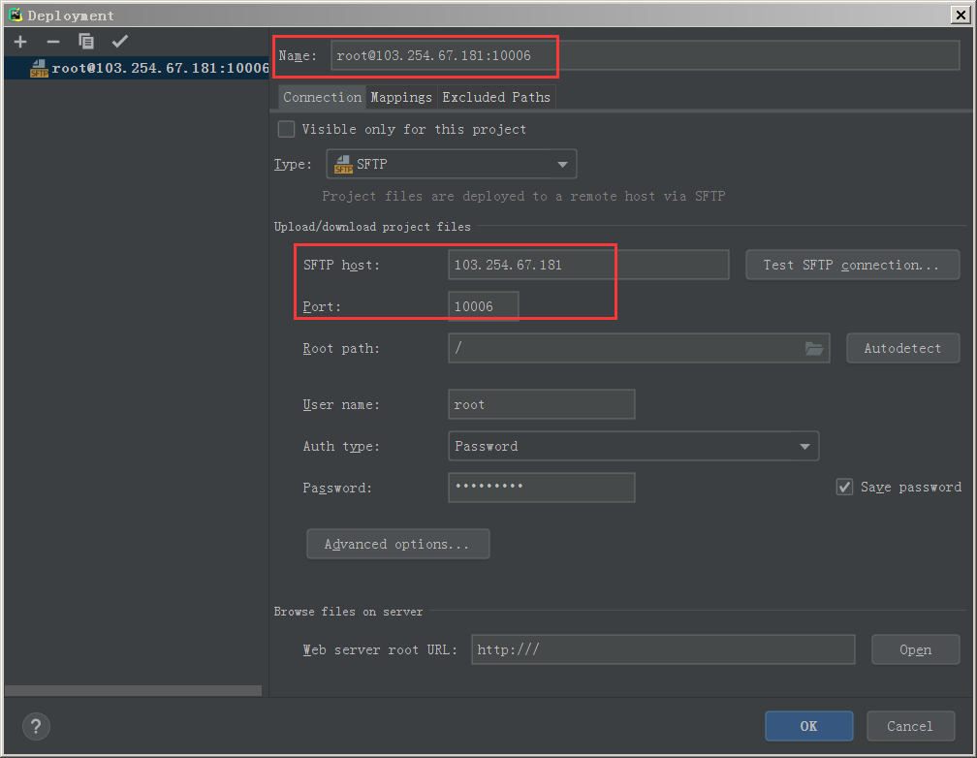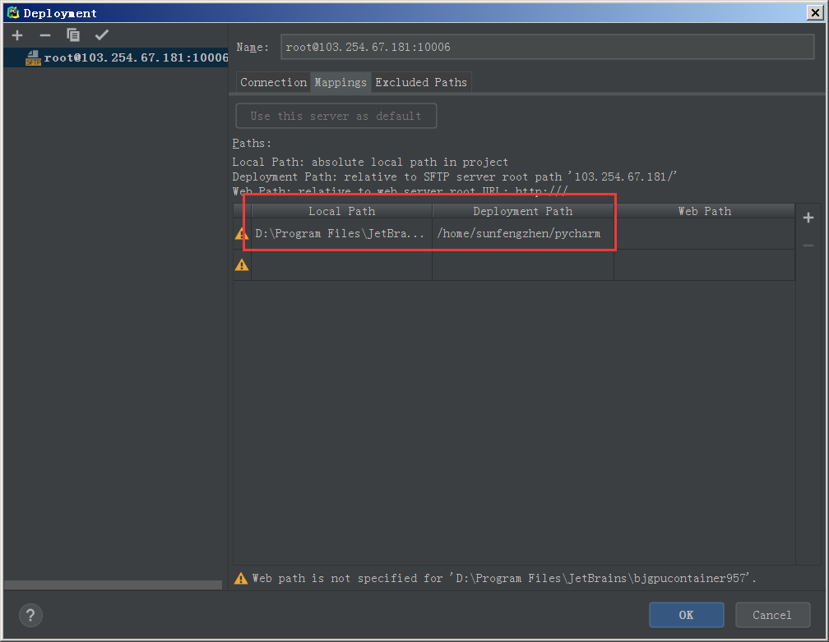
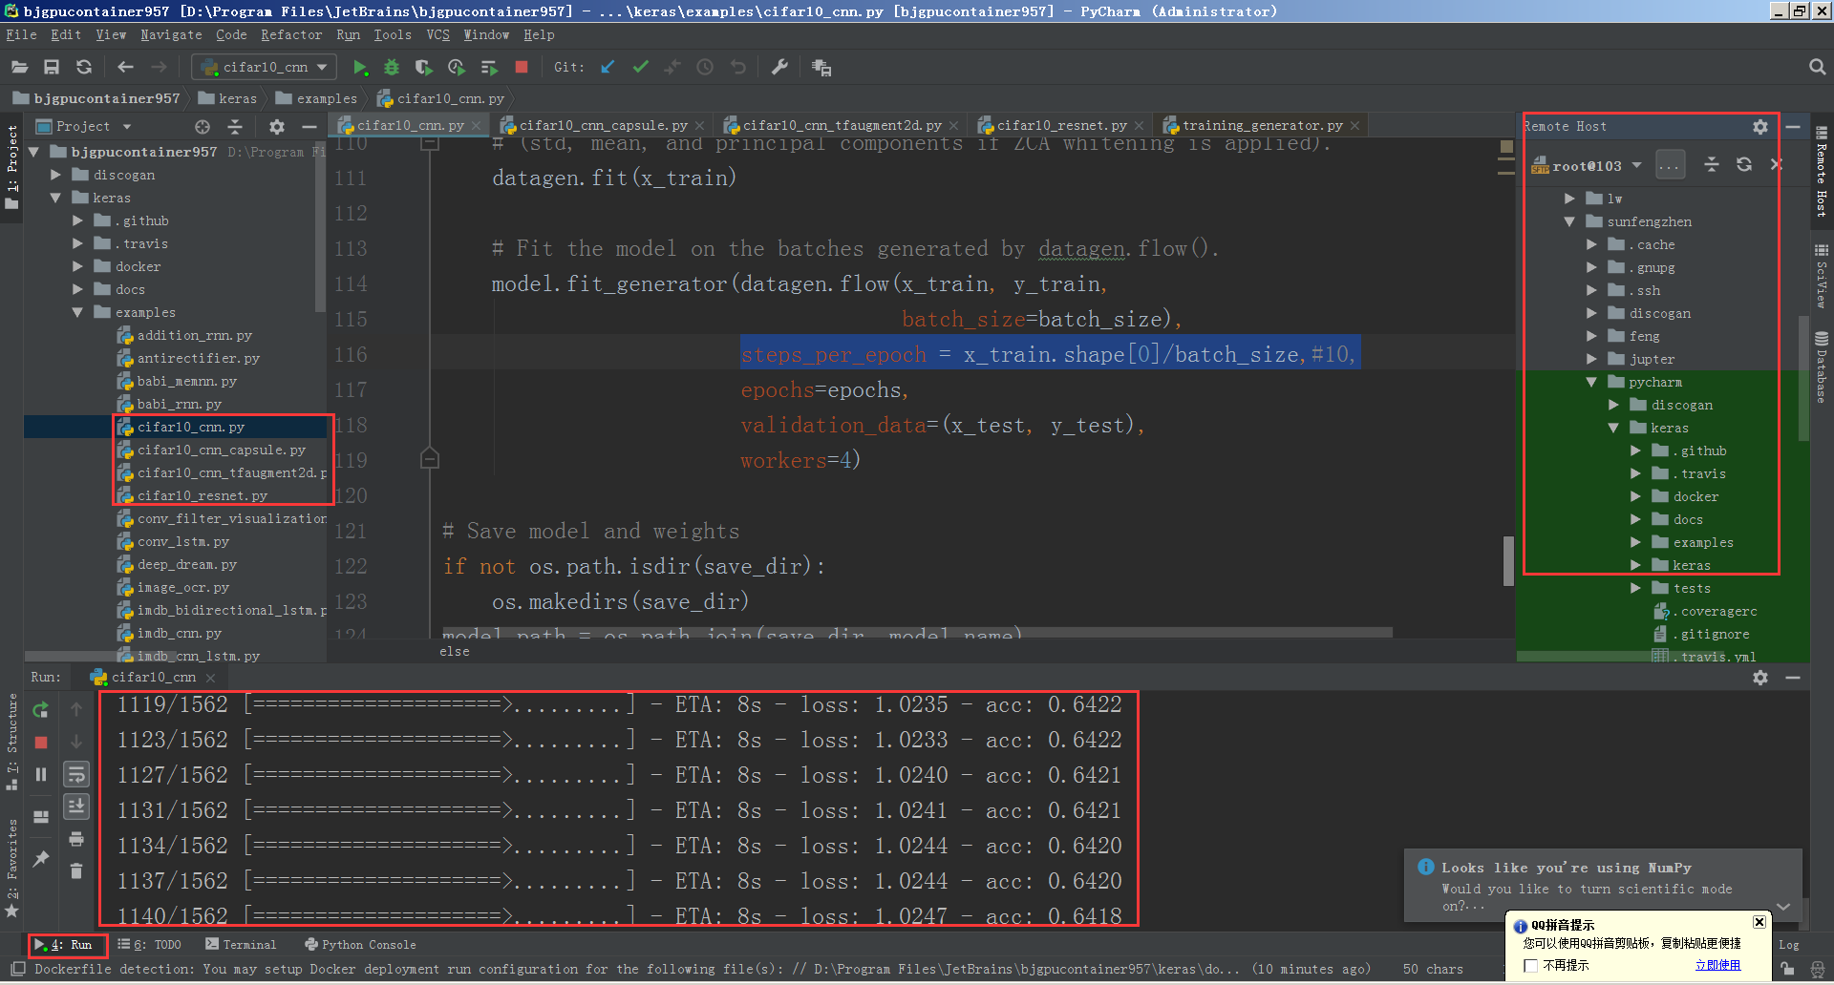
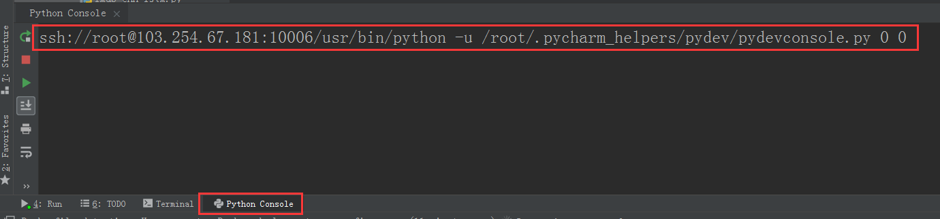

运行：
Cifar10_cnn.py
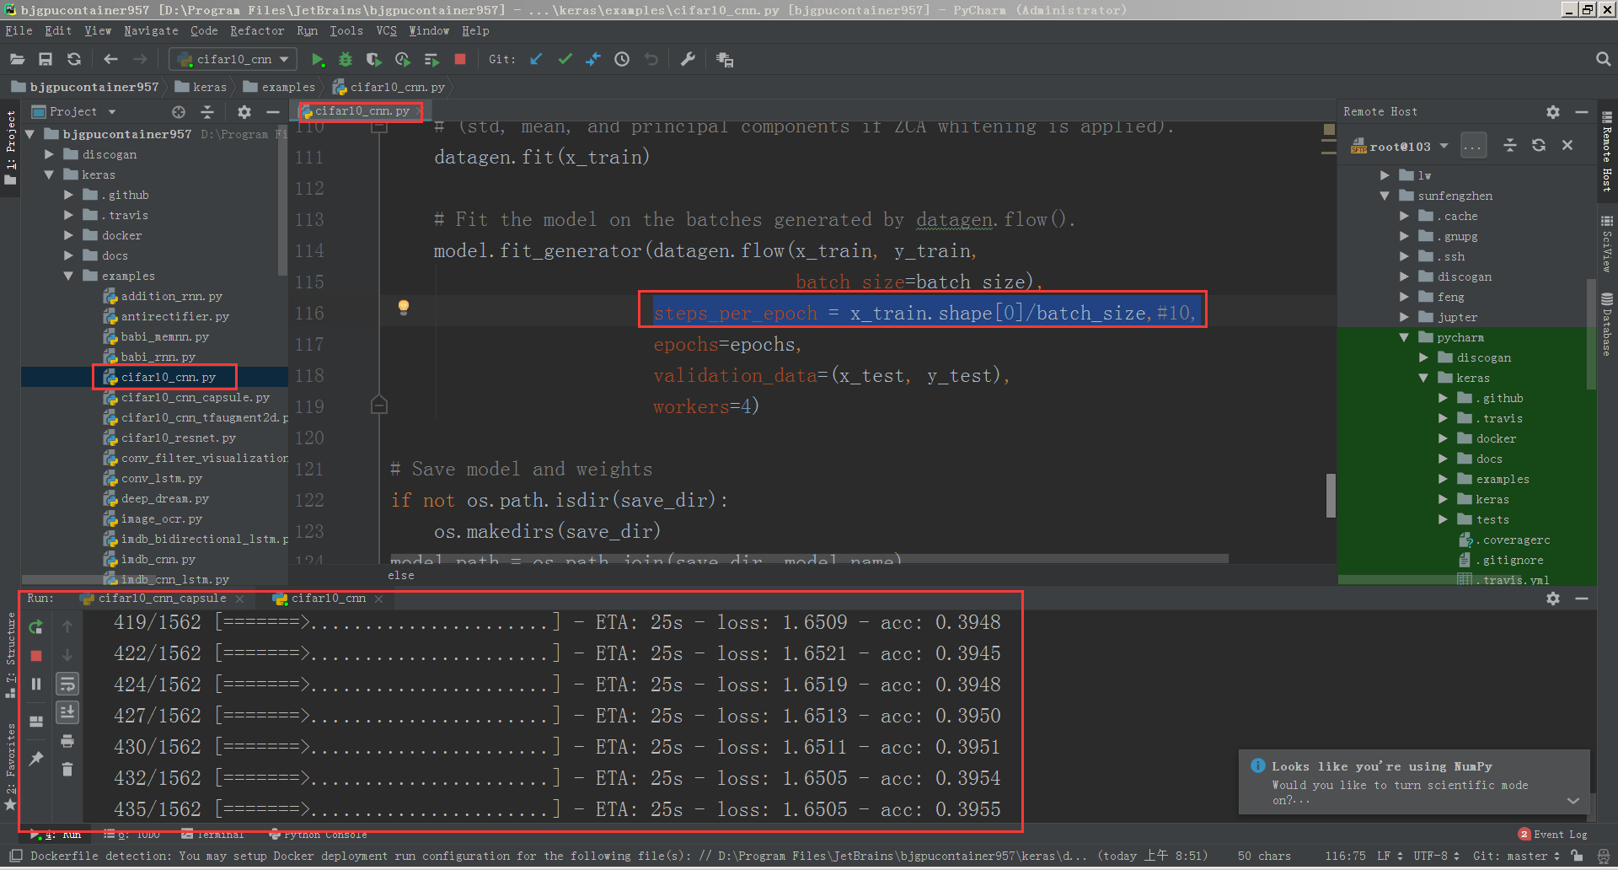
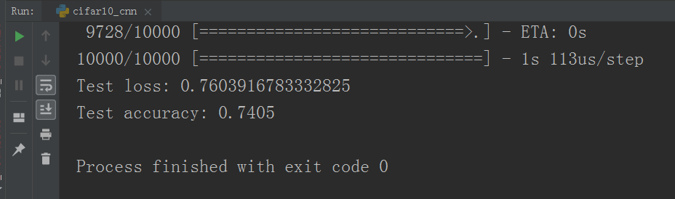
Cifar10_cnn_capsule.py
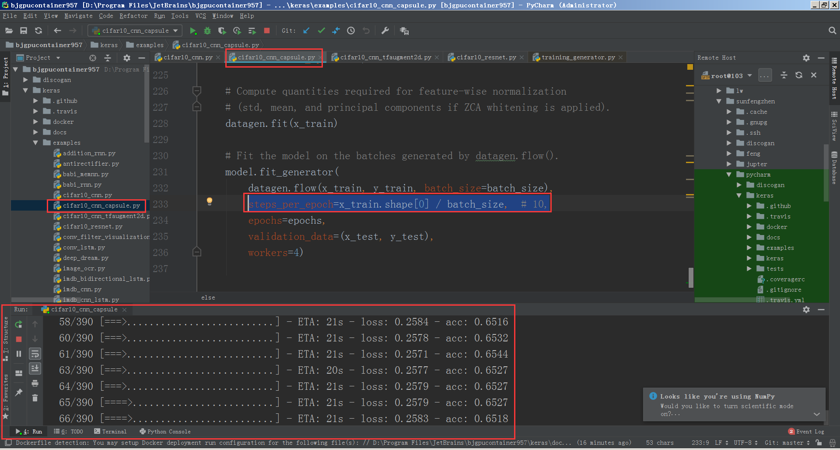
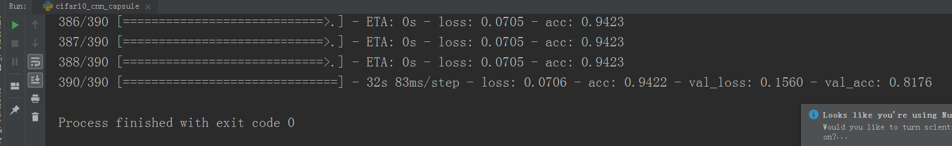
Cifar10_cnn_tfaugment2d.py
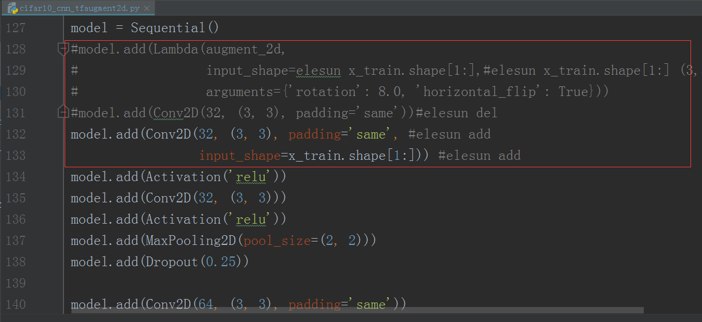
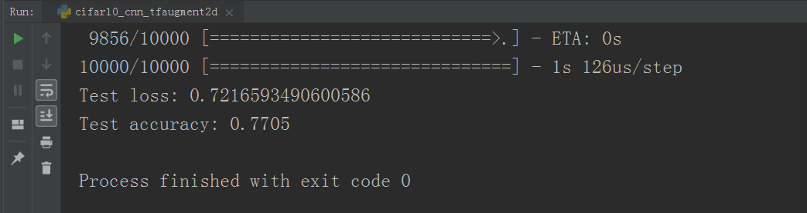
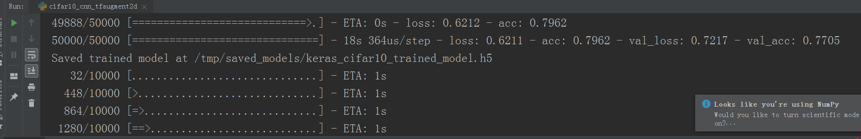
Cifar10_resnet.py
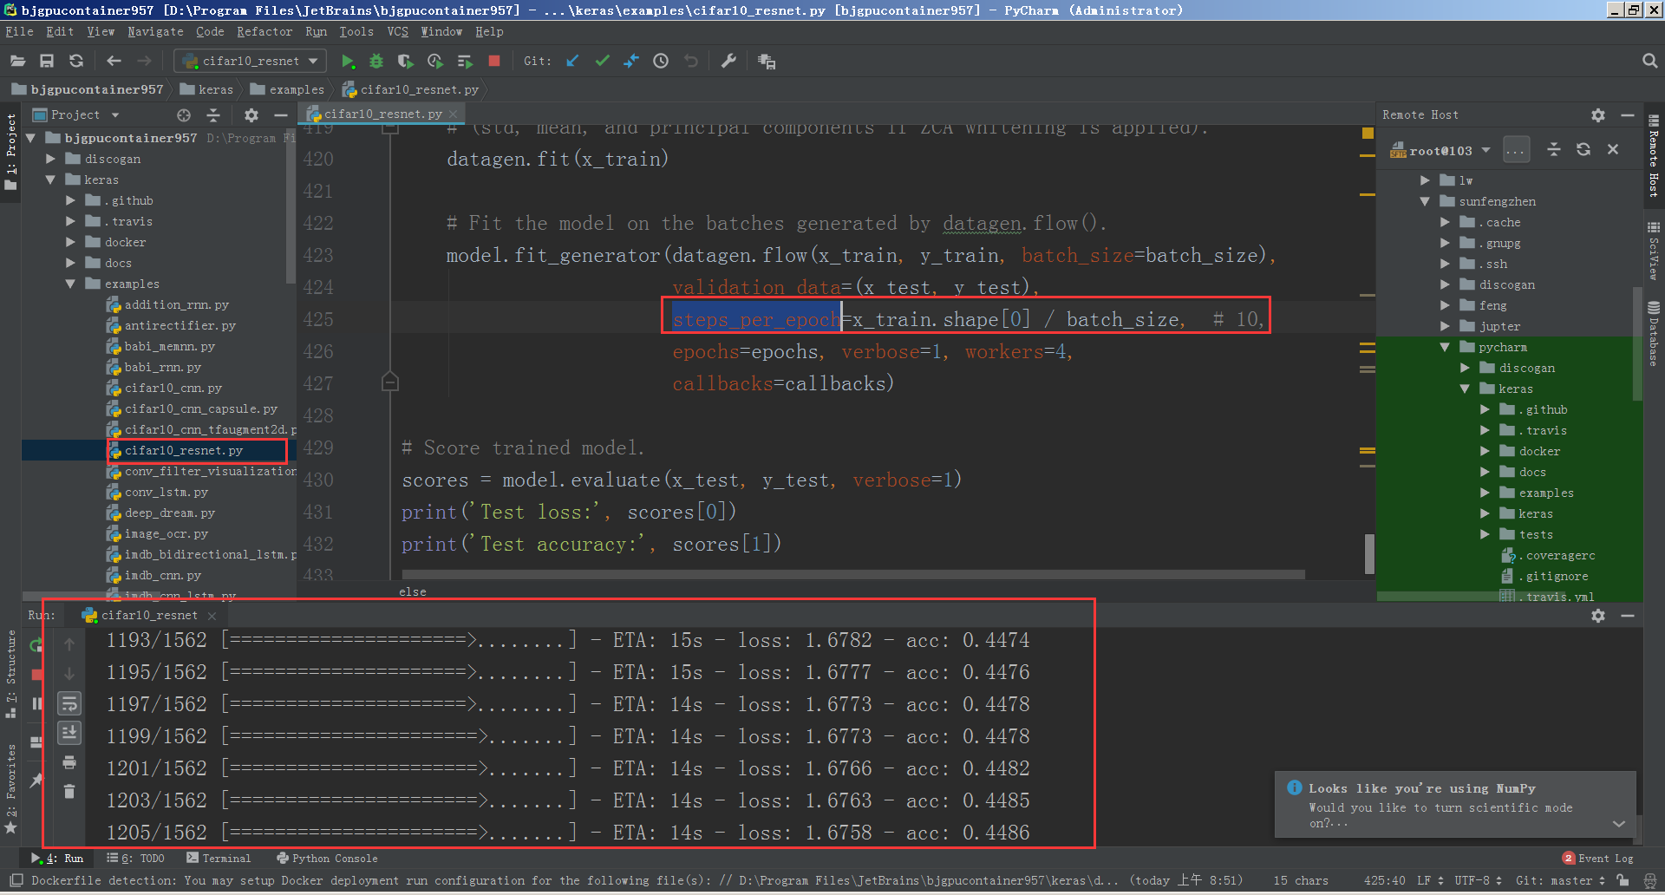
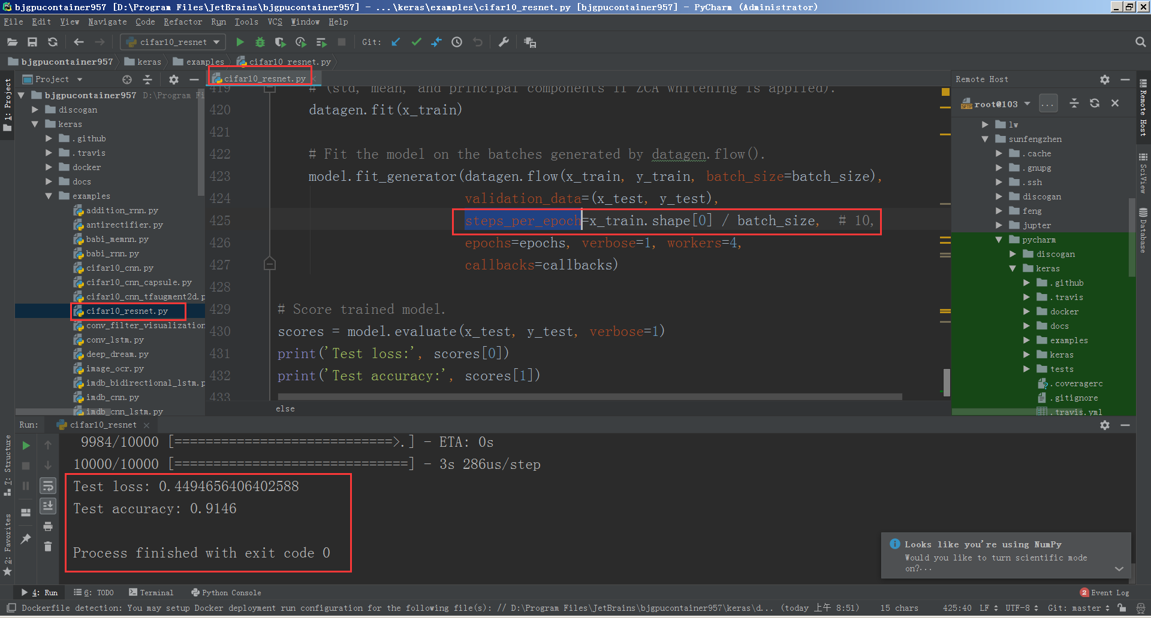
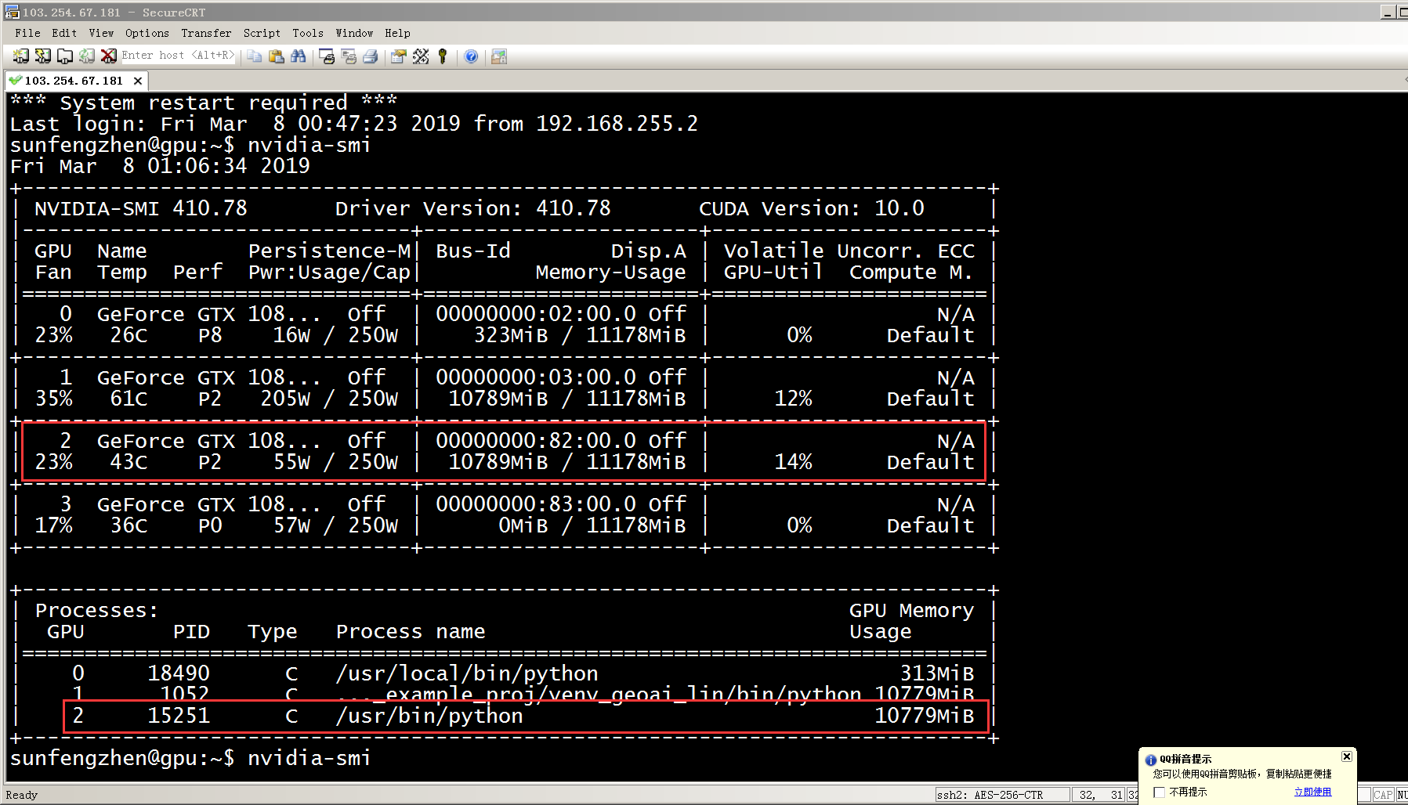
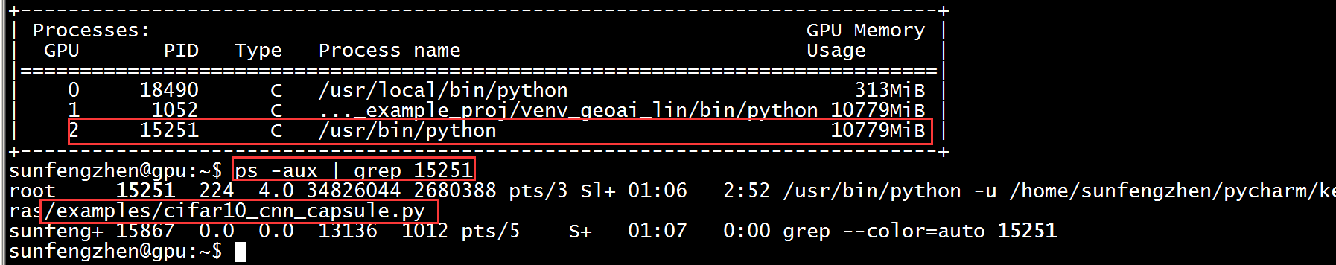

问题：
AttributeError: 'module' object has no attribute 'to_categorical'
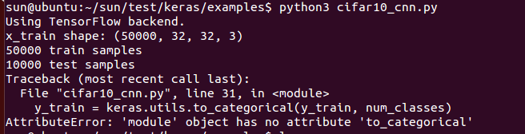
sun@ubuntu:~/sun/test/keras/examples$ sudo pip2 install keras==2.2.4
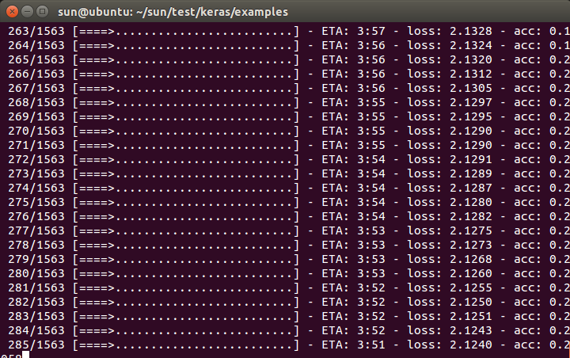
OK

ValueError: `steps_per_epoch=None` is only valid for a generator based on the `keras.utils.Sequence` class. Please specify `steps_per_epoch` or use the `keras.utils.Sequence` class.
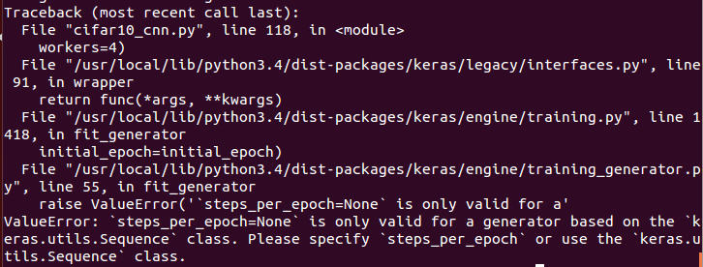
sun@ubuntu:~/sun/test/keras/examples$ python3 cifar10_cnn.py
换python2
sun@ubuntu:~/sun/test/keras/examples$ python2 cifar10_cnn.py
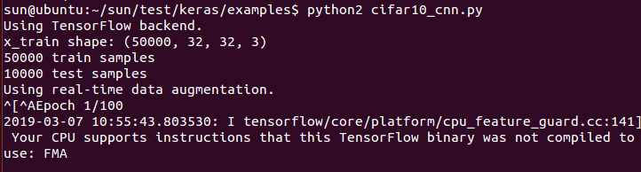
OK
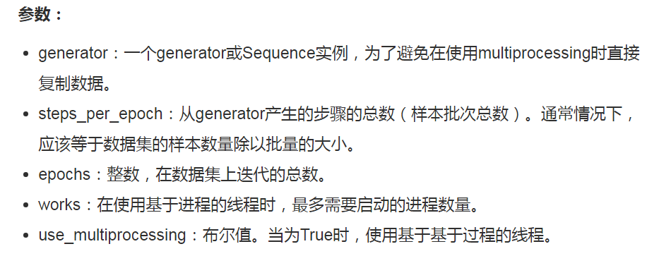
- steps_per_epoch: Integer or None. Total number of steps (batches of samples) before declaring one epoch finished and starting the next epoch. When training with input tensors such as TensorFlow data tensors, the default None is equal to the number of samples in your dataset divided by the batch size, or 1 if that cannot be determined.
steps_per_epoch = x_train.shape[0]/batch_size,#10,
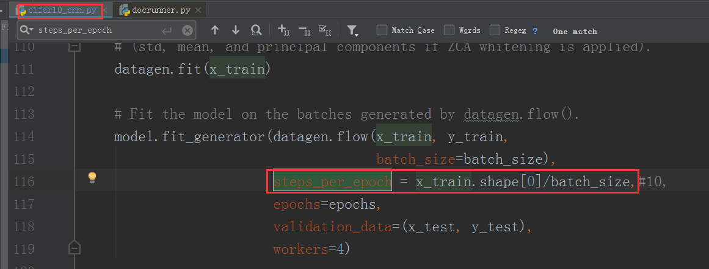
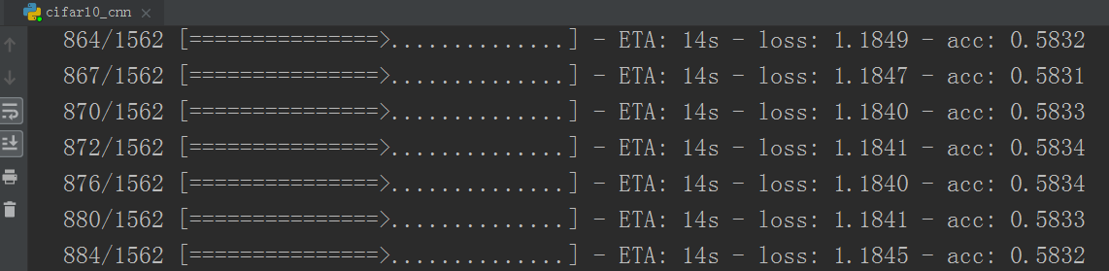
OK

ValueError: The shape of the input to "Flatten" is not fully defined (got (None, None, 64). Make sure to pass a complete "input_shape" or "batch_input_shape" argument to the first layer in your model.
